Purpose
College life is an important part of our life. This step is a preparation to go to society. I want to be a CEO of a big company in the future. I like to learn computer programing. That’s why computer science is my major. I love computer science. I want to know some jobs that I can do with computer programing which I love a lot. My dream is to be a person who earns a lot of money by working that I love and donate the money to society. The purpose of this project is to help me find a suitable job.

Discussion
- S.M.A.R.T goals
I want to be a helpful person by becoming a CEO in the future. ‘Helpful’ is meaning vast and abstract. Therefore, I have several specific goals to achieve the ultimate goal.
- Participating in computer science projects
R(realistic)-I am a member of computer science club. Members meet once a week on Friday. S(specific)-We have plan to conduct a project which is about making a ‘clicker’. Clicker is a machine for checking attendance. T(timely)-We are going to make a prototype of the clicker in 6 months. A(attainable)-This is just prototype, and utilize the technique that I learn in computer science class. So, I think we can make it. M(measurable)-After we make a real prototype, we will sell it. The reason I participate in this program is that I can learn a process of invent a stuff which is a part of company.
- Get A in all subjects
I take 5 classes in this semester. Those are Calculus 1, UNIV 1000, composition 1, computer science and visual art. A(attainable)-The grades on each subject are good so far except visual art. I have to more concentrate on visual art more. But it is still attainable because I have 2 more tests. T(timely)-In other words, finishing of the course will be 2 months later when I can keep up my score enough. M(measurable)-I need great scores to get into big companies for my dream which is CEO in a good company. S(specific)-I am going to review every day after class to achieve this goal. R(realistic)-Library closes at 10:45 PM every week days. It is not impossible to finish reviewing until library closes. Even though I want to play after class, I need to avoid it.

- Finance
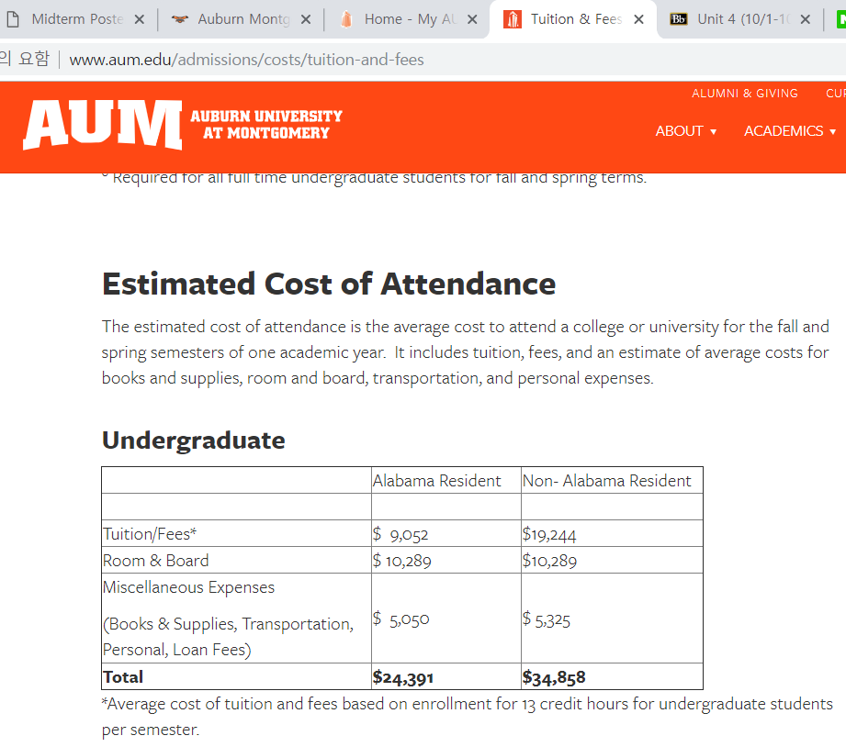
Although I am an international student, I have L-2 visa, I am separated as an Alabama Resident, so fees to graduate is $24,391. But my visa is expired in 2020. I will renew my visa to F-1. Therefore, I have to pay as a resident for 4 semesters, and pay as an international student for 4 years. 12195 + 17429 = 29624 $ is needed for graduation. My parents spend these fees for me rather than loan.
If I go to a big company, I will earn a lot of money. For example, the first annual salary of Hyundai MOBIS which is a big company making cars is about 40000$.

Focus 2
In the section of Work Interest Assessment, it shows that I like a job which is realistic, conventional and investigative. According to the part of Values Assessment, it says I seek to a job that I can help society, which needs creativity and make a high income. Skills Assessment discusses I prefer a job which needs skills of computer programming, decision making and mathematics. Lastly, Leisure Interest Assessment shows that says I am the thinkers, the doers and the persuaders. Those four sections explain that I’m fit for being CEO. However, personality assessment shows that the jobs which are suitable for me are field of counseling, teaching, health sciences, psychology, arts and literature. These are not about CEO. Even though my personality is suitable for those fields of jobs, I will work hard to be a CEO. Explanation of tutor in O*Net is not fit for me. I need to use skills of computer programming in some fields of tutors, I have to teach same things regularly.

Works cited
- Aum.edu. tuition & fee.
http://www.aum.edu/admissions/costs/tuition-and-fees
accessed October 8, 2018.
- O*Net Online - tutor
https://www.onetonline.org/link/summary/25-3099.02
accessed October 8, 2018

- Focus 2 – self assessment
http://www.focus2career.com/LoggedIn/MainMenu.cfm?Unique={ts%20%272018-10-07%2023:34:10%27}&SID=673&CFID=38141237&CFTOKEN=19c11e0fee83ad18-3155EA5F-B82A-72DD-7468F9E7CE8F9BDF
accessed October 8, 2018
- College Success Auburn University at Montgomery-David L. Strickland, Carol J. Strickland.
Accessed October 8, 2018
Published in 2017.
- Ten Ways To Think About Writing : Metaphoric Musings for College Writing Student, a chapter in Writing Spaces : Readings on Writing, Volume 2. – E. Shelly Reid, repr inted in 2011



Plan of study

I express the semester that I want to take the class as numbers. Now is first semester. And next is 2nd. The final semester is 8th .
I want to study TOEFL for my English skill too. Although this is not related to my major, I have to prove my level of English. Therefore, I will get 110/120 until 2019.

